# Module 7 Assignment

**Steps**:

1. Create a Dictionary object containing course numbers and the room numbers.

Dictionary of type: string ,string (ZyBooks,2019).

dict_room_number = {

"CSC101":"3004",

"CSC102":"4501",

"CSC103":"6755",

"NET110":"1244",

"COM241":"1411"

}

1. Create a Dictionary object containing course numbers and the names of the instructors.

Dictionary of type: string ,string (ZyBooks,2019)

dict_instructors = {

"CSC101":"Haynes",

"CSC102":"Alvarado",

"CSC103":"Rich",

"NET110":"Burke",

"COM241":"Lee"

}

1. Create a Dictionary object containing course numbers and the meeting times of each course.

Dictionary of type: string ,string (ZyBooks,2019)

dict_meeting = {

"CSC101":"8:00 a.m.",

"CSC102":"9:00 a.m.",

"CSC103":"10:00 a.m.",

"NET110":"11:00 a.m.",

"COM241":"1:00 p.m."

}

1. Logic building steps:
   1. Get an input from the user to type in course number and convert the string to upper.
   2. Iterate through Keys within dictionary objects. Here, the program is designed to check and make sure that the specific Key is present in all 3 dictionary objects (Classroom, Instructor, Meeting). This will avoid any Key not Found exception to occur.

if course_cd in (dict_room_number and dict_instructors and dict_meeting):

print('\n\nInformation for the course:',course_cd)

print("Room:", dict_room_number[course_cd], "Instructor:",dict_instructors[course_cd], "Meeting at:", dict_meeting[course_cd])

* 1. Get the values from dictionary objects by dict_room_number[course_cd

dictionary[Key] command (ZyBooks, 2019)

* 1. Display course Information for entered course number.
  2. Ask if the user wants to see details for another course number after each successful attempt until the user presses any key except ‘y’ or ‘Y’.

if input("\n\nDo you wish to check details for another course? Type 'Y' for yes or press any key to Quit.\n").upper() == 'Y':

continue

* 1. If the user had entered the wrong course number, the program shows a user-friendly message and shares the course number of all courses if the course number is present commonly in all dictionary objects.

print("Course info not available for the course number you entered.\nCurrently, Schedule is available for these courses:")

for key in (dict_room_number and dict_instructors and dict_meeting):

avail_courses += (key + ' ')

print(avail_courses)

* 1. This program runs in do while loop logic until the user selects to Exit or maximum fail attempt count or any Exception (Python, 2022).

while (fail_count < MAX_FAIL_COUNT):

try:

course_cd = input('Please enter a Course Number to view schedule.\n').upper()

avail_courses = ''

if course_cd in (dict_room_number and dict_instructors and dict_meeting):

print('\n\nInformation for the course:',course_cd)

print("Room:", dict_room_number[course_cd], "Instructor:",dict_instructors[course_cd], "Meeting at:", dict_meeting[course_cd])

if input("\n\nDo you wish to check details for another course? Type 'Y' for yes or press any key to Quit.\n").upper() == 'Y':

continue

else:

print("Enjoy your Learning journey!!\n")

break

else:

fail_count += 1

if ( fail_count == MAX_FAIL_COUNT):

print('\nMax allowed count of error reached. Please try again later.\n')

break

else:

print("Course info not available for the course number you entered.\nCurrently, Schedule is available for these courses:")

for key in (dict_room_number and dict_instructors and dict_meeting):

avail_courses += (key + ' ')

print(avail_courses)

except:

fail_count += 1

print("Error. Something went wrong. Please try again.")

* 1. The entire program logic within try except block so, if any exceptions occur, it can be caught and can be handled gracefully by displaying user friendly messages in such cases (GeeksforGeeks,2023).

**GIT link for source code:**

<https://github.com/nshahcsu/MSAI/blob/main/CS500/Module%207/course_schedule.py>

**Screen Shots:**

1. If a course is found.

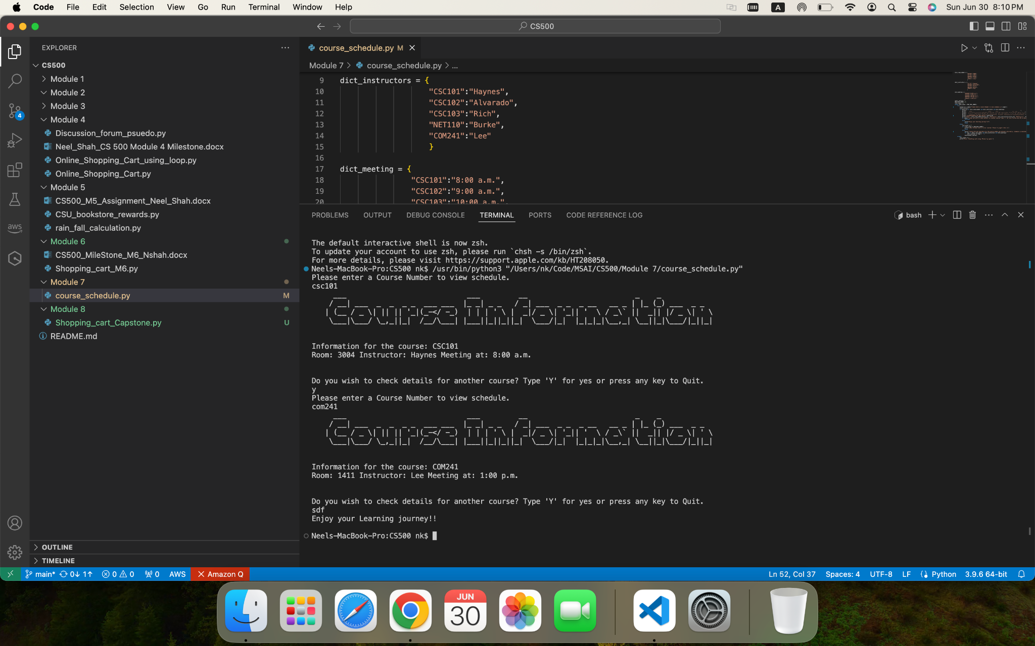

1. If a course is not found:

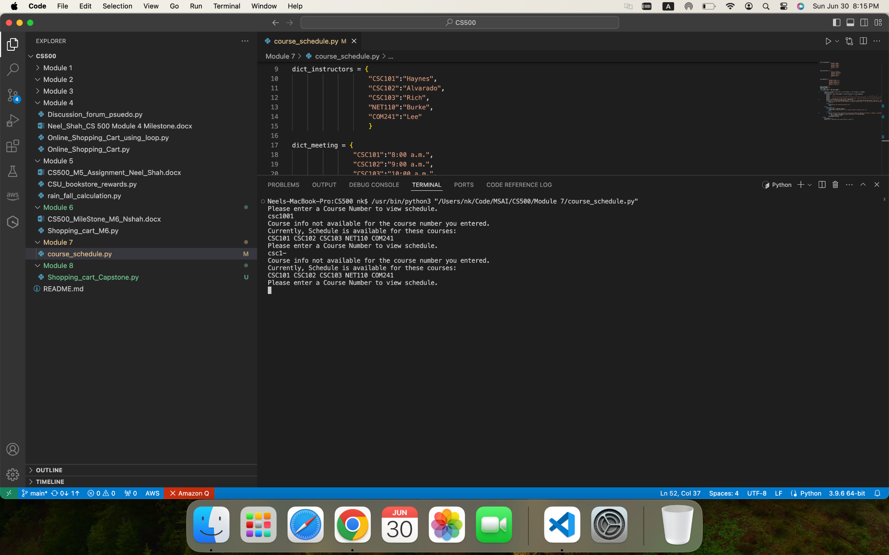

**References:**

GeeksforGeeks. (2023, April 13). Python try except. GeeksforGeeks.

https://www.geeksforgeeks.org/python-try-except/

Python, R. (2022, July 18). Python “while” Loops (Indefinite Iteration).

https://realpython.com/python-while-loop/

ZyBooks. (2019 August). CSC500: Principles of Programming. Module 6.